Some problems when installing Android Studio

**Problem1：no emulator installed**

这个问题可能是因为没有把电脑上的杀毒软件关掉，导致运行模拟器的时候被移除了。衷心希望大家不要遇到我这个问题！万一遇到了就照下面做吧（亲测有效）：

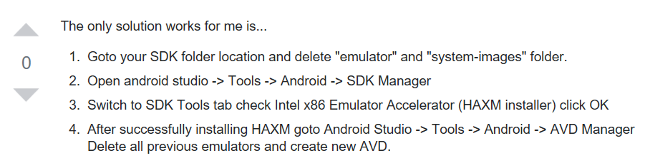

SDK folder location：

C:\Users\yuyelong\AppData\Local\Android\Sdk\extras\intel\Hardware_Accelerated_Execution_Manager

“emulator” and ”system-images” folder is located at:

C:\Users\yuyelong\AppData\Local\Android\Sdk

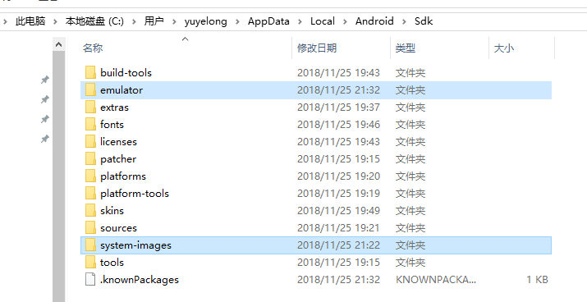

<https://stackoverflow.com/questions/40181450/android-studio-emulator-error-intel-haxm-is-required-no-emulator-installed>

**Problem2：enable VT ( Intel virtualization technology)-x in your bios security**

进入BIOS将**Intel virtualization technology这一项使能即可。**

<https://www.cnblogs.com/sunyl/p/5915144.html>

Finally there goes the good result:

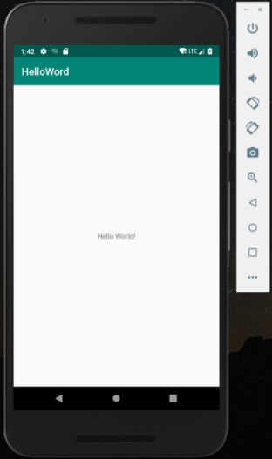 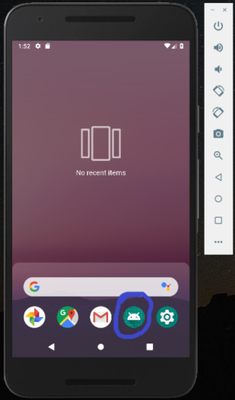

针对oppo r11手机Android Studio的一次开发经历

（调用摄像头20181128）

1、使用butterknife

<https://blog.csdn.net/qq_31852701/article/details/80312719>

<https://blog.csdn.net/qq_33792946/article/details/53816552>

<https://blog.csdn.net/u010937230/article/details/60762472>

<https://blog.csdn.net/androidwubo/article/details/78835706>

<https://blog.csdn.net/qq_31852701/article/details/80312719>

项目下面的build.gradle

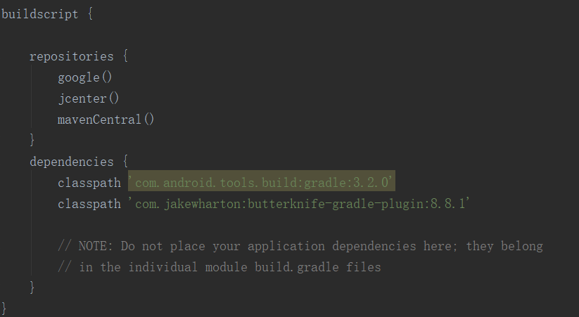

app下面的build.gradle

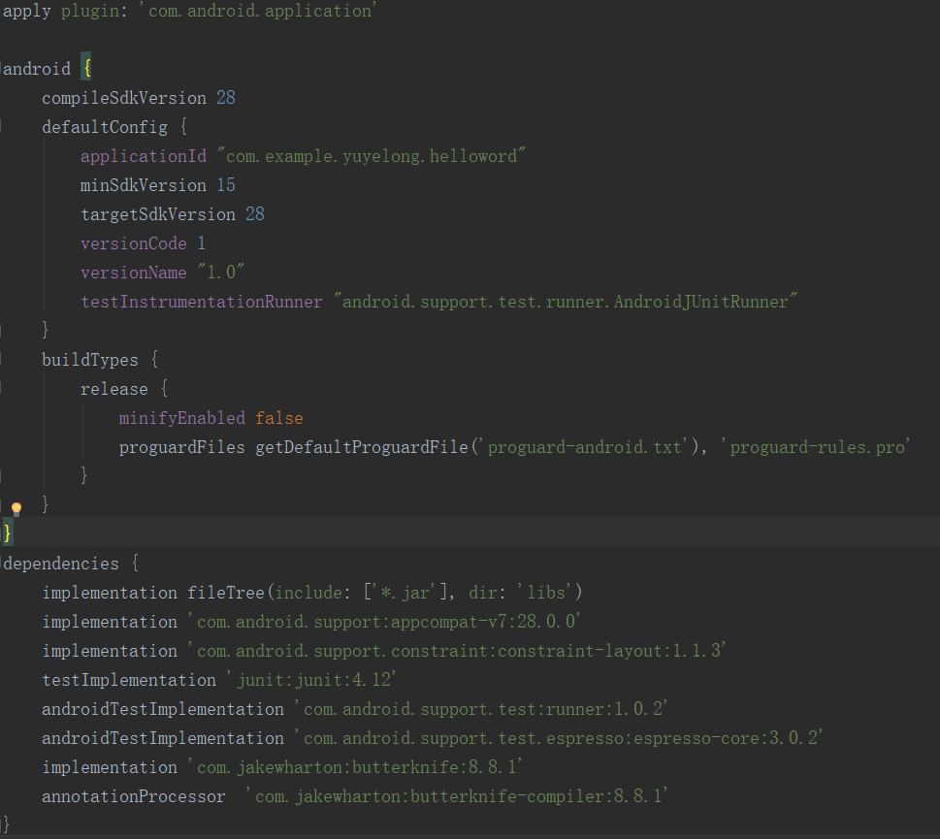

2、activity code:

<https://blog.csdn.net/qq_33792946/article/details/54094307>

package com.example.yuyelong.helloword;  
  
import android.content.Intent;  
import android.graphics.Bitmap;  
import android.os.Bundle;  
import android.support.v7.app.AppCompatActivity;  
import android.widget.Button;  
import android.widget.ImageView;  
  
import butterknife.BindView;  
import butterknife.ButterKnife;  
import butterknife.OnClick;  
  
public class HelloWorldActivity extends AppCompatActivity {  
 @BindView(R.id.*button_1*)  
 Button button_1;  
 @BindView(R.id.*imageIV*)  
 ImageView imageIV;  
  
 private final int CAMERA_REQUEST = 8888;  
  
 @Override  
 protected void onCreate(Bundle savedInstanceState) {  
 super.onCreate(savedInstanceState);  
 setContentView(R.layout.*activity_hello_world*);  
 ButterKnife.*bind*(this);  
 }  
  
 @OnClick(R.id.*button_1*)  
 public void onClick() {  
 Intent cameraIntent = new Intent(android.provider.MediaStore.*ACTION_IMAGE_CAPTURE*);  
 startActivityForResult(cameraIntent, CAMERA_REQUEST);  
 }  
  
 @Override  
 protected void onActivityResult(int requestCode, int resultCode, Intent data) {  
 if (requestCode == CAMERA_REQUEST && resultCode == *RESULT_OK*) {  
 Bitmap photo = (Bitmap) data.getExtras().get("data");  
 imageIV.setImageBitmap(photo);  
 }  
 }  
}

3、针对oppo r11手机安装apk问题：

在gradle.properties上加一句：这样以后安装没问题，但是还是会出现闪退的现象。

android.injected.testOnly=false

oppo手机安装apk后闪退的处理：

<https://blog.csdn.net/zhao8856234/article/details/79958867>

在settings里面去掉下面这个功能：

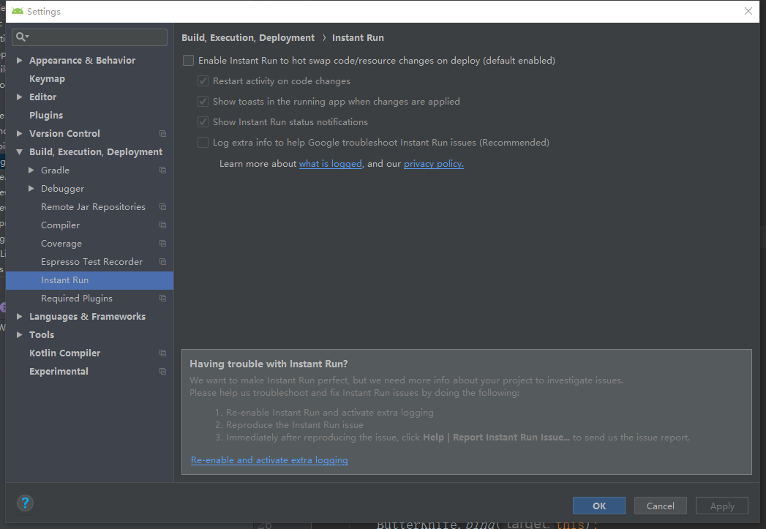

生成签名文件请参考《第一行代码》15.1

其中key store path的路径除了文件夹再加上自己的新命名jks文件即可

4、打开oppo手机的开发者选项参考：版本号点五下，还有这种骚操作真是

<https://jingyan.baidu.com/article/a501d80c37cc83ec620f5e5d.html>

<https://blog.csdn.net/yeyuewushang/article/details/80179803>

1. 结果

